**Problem 1:**

#include <stdio.h>

int main() {

int sub1, sub2, sub3, total;

float percentage;

printf("Enter marks of 3 subjects: ");

scanf("%d %d %d", &sub1, &sub2, &sub3);

total = sub1 + sub2 + sub3;

percentage = (total / 300.0) * 100;

printf("Total Marks = %d\n", total);

printf("Percentage = %.2f%%\n", percentage);

return 0;

}

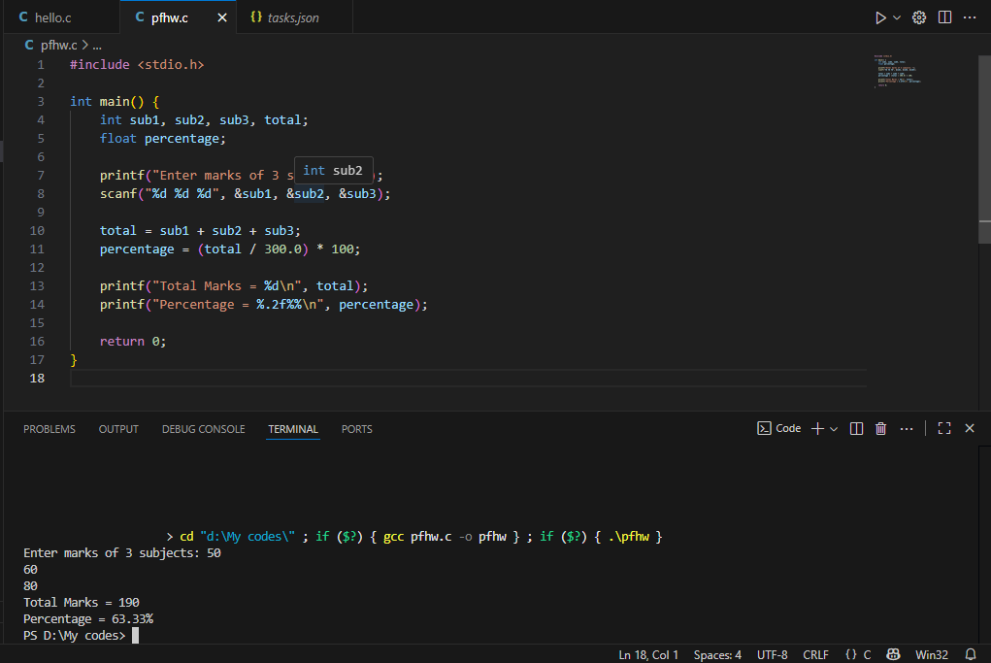

**Problem 2:**

#include <stdio.h>

int main() {

int a, b, temp;

printf("Enter two numbers: ");

scanf("%d %d", &a, &b);

temp = a;

a = b;

b = temp;

printf("After swapping: a = %d, b = %d\n", a, b);

return 0;

}

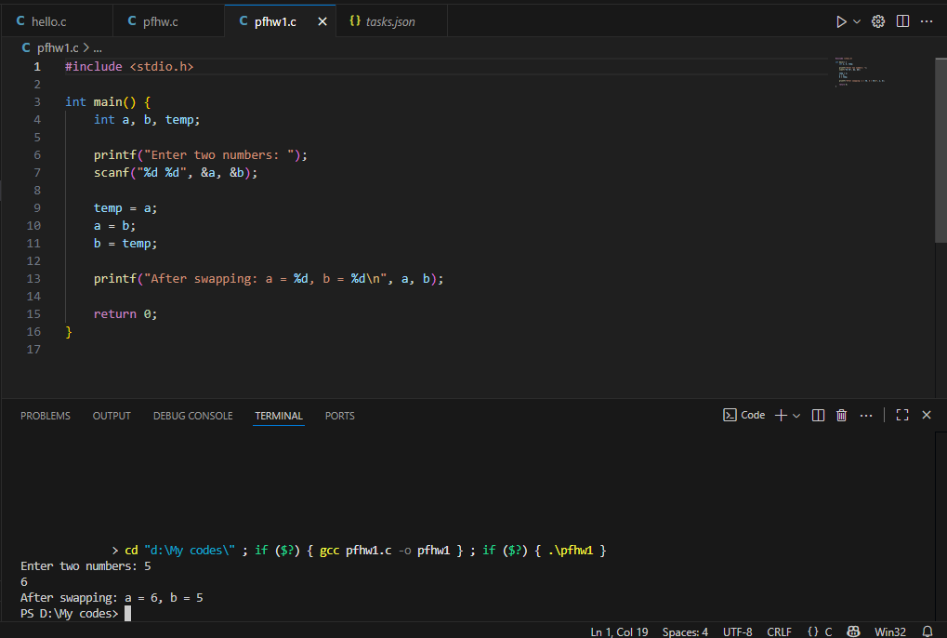

**Problem 3:**

#include <stdio.h>

int main() {

int num;

char ch;

printf("Enter an integer (65–90): ");

scanf("%d", &num);

ch = (char)num;

printf("%d = %c\n", num, ch);

return 0;

}

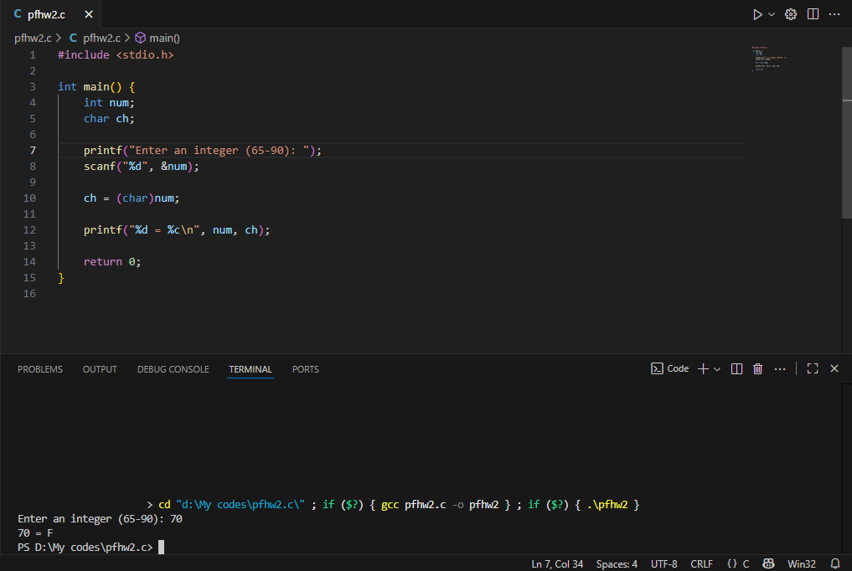

**Problem 4:**

#include <stdio.h>

int main() {

float basic, hra, da, gross;

printf("Enter basic salary: ");

scanf("%f", &basic);

hra = basic * 0.10;

da = basic * 0.05;

gross = basic + hra + da;

printf("Gross Salary = %.2f\n", gross);

return 0;

}

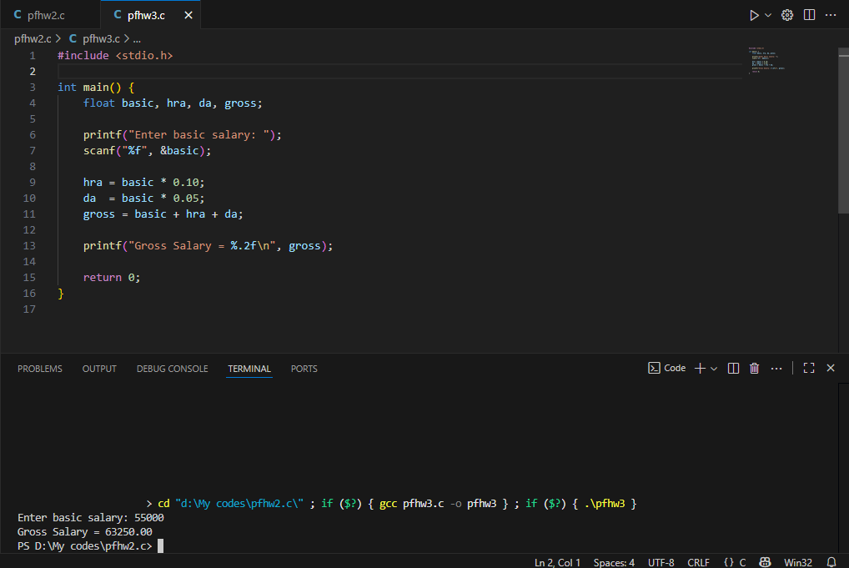

**Problem 5:**

#include <stdio.h>

int main() {

printf("Name: Ali\n");

printf("Age: 20\n");

printf("Course: \"C Programming\"\n");

printf("Result: Passed\n");

return 0;

}

